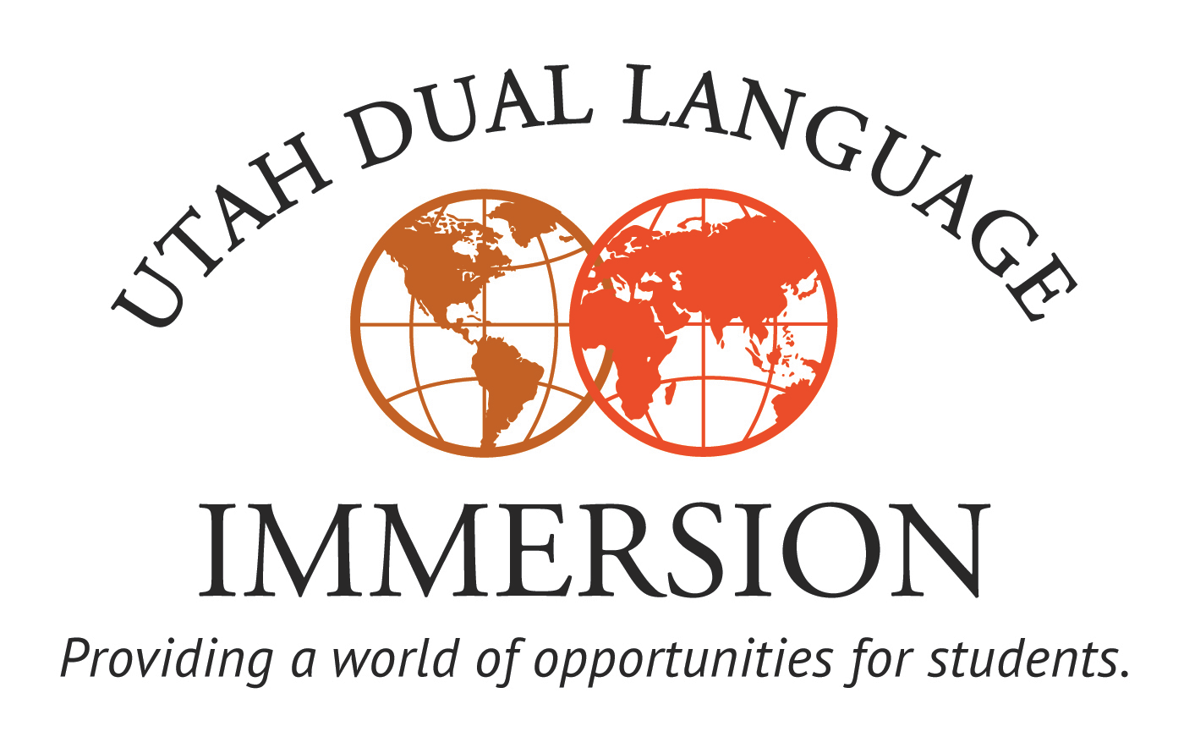
Dual Language Immersion Advisory Council
March 23, 2015 – Utah Valley University
9:00am-10:35am
- Networking (9:00-9:10am)
- Good News Moment
- Welcome to UVU – Baldomero Lago
- Informational Updates – Gregg Roberts
- Utah DLI Program Fidelity Assurances – Lois Lovell & Jamie Leite
- Proficiency for Principals – Brandee Mau
- What to Look for When Hiring DLI Teachers – Stacy Lyon & Ofelia Wade
- Utah’s Secondary DLI Continuation Courses: the K-16 Lens – Jill Landes-Lee
- Logistics – Sandra Talbot
Language Specific Breakouts
10:45am-11:30am

Chinese – Stacy Lyon (213A)
French – Kaye Murdock (206A)
German – Brandee Mau (206G)
Portuguese – Jamie Leite (206H)
Spanish – Ofelia Wade (206B&C)
ALL Secondary – Jill Landes-Lee (213B)

Lunch – Center Stage
11:45am-12:45pm

Director of Teaching & Learning at USOE, Diana Suddreth
Dean of the College of Education at UVU, Parker Fawson

Next Meeting
Monday, October 12, 2015 – University of Utah

